Medicaid, Disease Burden, and the Populations Most Vulnerable to Community Health Center Disruption Under the OBBBA
Tobi Owoyemi

Background
The Affordable Care Act (ACA) has expanded access to healthcare for millions of Americans since its inception in 2010. The primary vehicle of expansion was through Medicaid, in which (1) categorical restrictions were removed for the expansion group, (2) an individual income at 138% of the federal poverty line became the standard to qualify for health insurance coverage, and (3) having a child was no longer a requirement. At its peak, the ACA reduced the uninsurance rate from 16% to 7.7%. However, the passage of the One Big Beautiful Bill Act (OBBBA) in July 2025 has made changes to Medicaid and the ACA that will cause the number of uninsured Americans to rise to 16 million within the next ten years.
As loss of health insurance coverage increases due to churn and recurring eligibility redeterminations, safety-net providers such as Community Health Centers (CHCs), also known as Federally Qualified Health Centers (FQHCs), will be significantly impacted. CHCs serve as critical pillars within local communities and the broader healthcare ecosystem, providing accessible and continuous care to underserved populations. When these populations experience instability in health insurance coverage, the systems designed to support them are also strained. As patient coverage becomes fragmented, CHCs may face disrupted care continuity, reduced reimbursement, and increased reliance on uncompensated care, thereby weakening their overall effectiveness.
This analysis constructs a utilization profile of Medicaid users who are structurally dependent on the program: they face a high disease burden, encounter barriers to access, and rely on CHCs for care. CHCs serve as essential components of a broader care ecosystem. By examining the utilization and vulnerability profile of this population, the analysis demonstrates how the OBBBA disrupts not only individual coverage, but also the structural relationships that sustain access to care in communities with disparate health outcomes.
Research Questions & Hypothesis
Primary Question: How are socioeconomic factors associated with Medicaid coverage and the prevalence of select chronic and behavioral health conditions?

Secondary Question: Controlling for demographic and socioeconomic factors, how are Medicaid coverage and disease burden associated with reliance on non-hospital care?

Policy Question: How are OBBBA-related Medicaid coverage losses likely to affect populations most reliant on CHC care, and what are the likely downstream implications for CHC utilization and operational risk?

The hypothesis is as follows:
- Racial/ethnic minority and lower-income populations are more likely to be covered by Medicaid.
- Racial/ethnic minority and lower-income populations have a higher prevalence of select chronic and behavioral health conditions.
- These groups are associated with higher utilization of non-hospital primary care.
- CHCs are non-hospital primary care providers that are important safety-net providers for populations with these specific health burdens.
- These groups are more vulnerable to CHC-related access disruptions under Medicaid policy changes.

Conceptual Framework
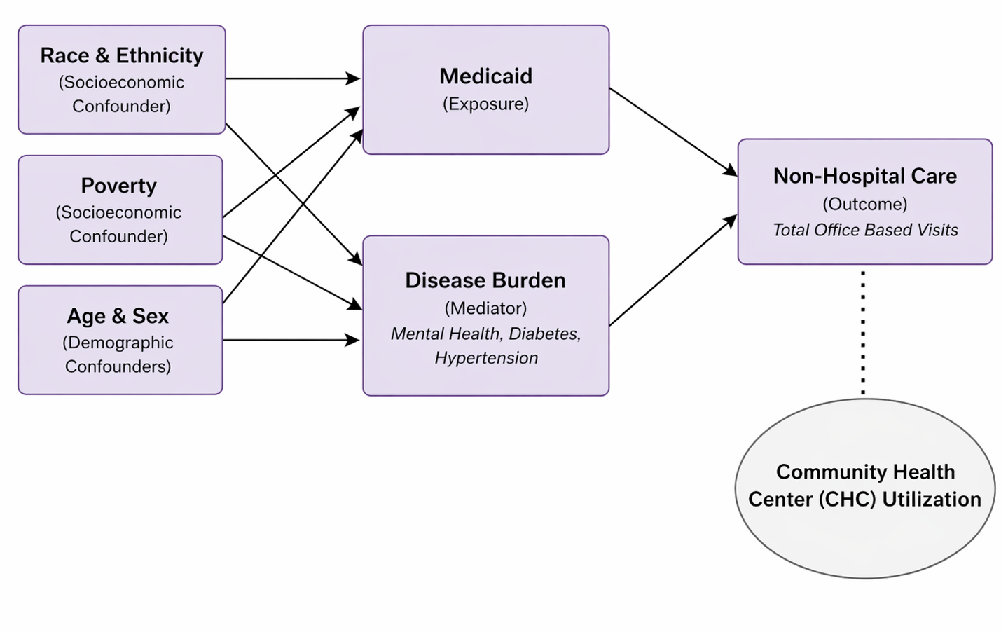
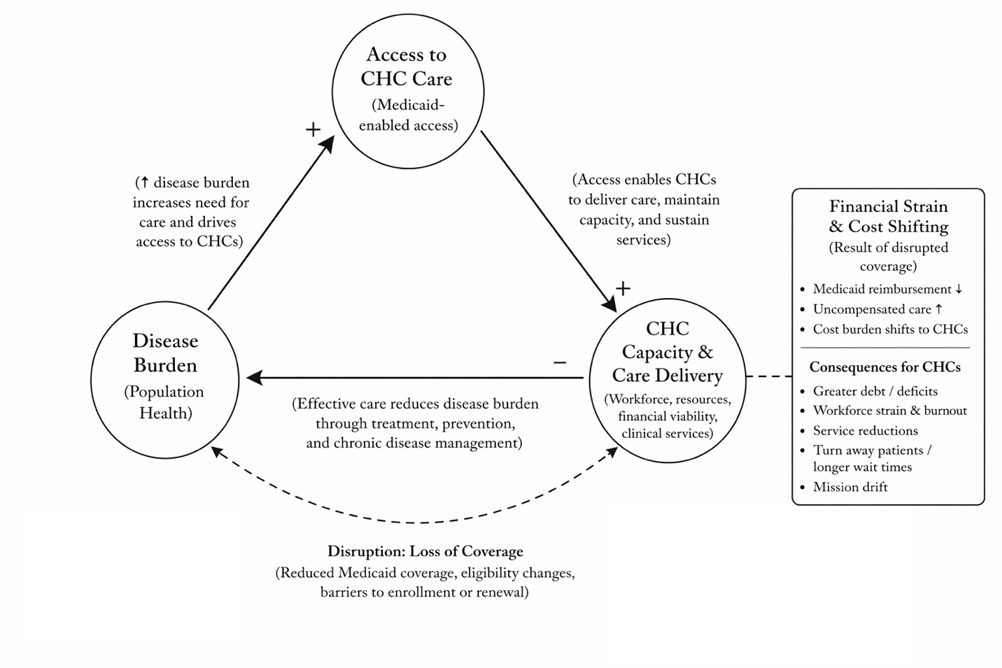
Image 1: This conceptual model illustrates two pathways through which sociodemographic factors shape reliance on non-hospital healthcare services. Medicaid coverage serves as the primary exposure of interest associated with access to care. Disease burden operates as a mediating health-need pathway through which social disadvantage contributes to greater reliance on outpatient, non-hospital care. Together, these parallel pathways help define the utilization profile of populations most reliant on non-hospital services, with CHC utilization situated as part of the broader outpatient care ecosystem.
Image 2: This conceptual model shows a system that is a balancing feedback loop where disease burden pushes demand up and CHCs push disease burden down. When CHCs are functional, disease burden is pushed down. However, disruptions to coverage limit access, leading to delayed care and increased disease severity. These changes place constraints on the provider safety-net. A reinforcing crisis loop is created where CHCs are unable to effectively manage population health.

Methods
The data for the research questions came from the Integrated Public Use Microdata Series (IPUMS) Medical Expenditure Panel Survey (MEPS) 2023 dataset. The MEPS population pool consists of the U.S. civilian noninstitutionalized population. It is a nationally representative, longitudinal sample drawn annually from households that participated in the previous year's National Health Interview Survey (NHIS). Individuals were surveyed concerning healthcare access and utilization patterns. The research methodology used was an observational, cross-sectional, quantitative study using secondary MEPS data. The dataset contains 18,919 observations and includes 50 variables. The data and distribution of variables was explored using STATA. The variables were dichotomized and analyzed using univariate, bivariate and regression-based multivariable analysis to identify patterns of vulnerability and access in the healthcare system.

The exposure variable used was Medicaid (HIMACHIP), which includes the Children’s Health Insurance Plan (CHIP) and is a dichotomous variable. The outcome variables used were Typical Place for Medical Care (TYPPLSICK) and Total Number of Visits Made to Office-Based Providers (OBTOTVIS). These variables are categorical and continuous, respectively. The covariates used were race (RACE_GRP) which is categorical, Hispanic ethnicity (HISPYN) which is dichotomous, poverty (POVERTY) which is dichotomous, Age (AGE) which is continuous, Sex (SEX) which is dichotomous, and disease burden which was dichotomized. Federal poverty level (POVLEV) was recoded from a continuous variable to a dichotomous variable to place the poverty threshold at below 100% of the federal poverty level, which was $14,580 for 2023. Disease burden consists of mental health disorders, diabetes, and hypertension. The mental health disorders were grouped under the Clinical Classification Software Refined (CCSR) Groups. The conditions used for this data set consist of: MBD002 Depressive disorders, MBD003 Bipolar and related disorders, MBD005 Anxiety and fear-related disorders, MBD007 Trauma- and stressor-related disorders, MBD013 Miscellaneous mental and behavioral disorders/conditions, and MBD025 Other specified substance-related disorders. These diseases were analyzed because they are the most prevalent diseases that CHCs treat for.
Descriptive statistics were used to characterize the study population across sociodemographic characteristics, Medicaid coverage, and disease burden. Frequencies and cross-tabulations were generated to examine distributions and initial associations between key variables. Bivariate analyses, including t-tests and cross-tabulations, were conducted to assess differences in non-hospital healthcare utilization across Medicaid status and disease burden indicators. Multivariable regression models were then estimated to examine the association between Medicaid coverage and non-hospital healthcare utilization, controlling for sociodemographic and demographic factors as well as measures of disease burden. Sequential models were specified to assess the incremental contribution of covariates. Given the count-based nature of the outcome variable (total office-based visits), both linear regression and Poisson regression models were estimated to evaluate the robustness of findings.
In addition to the quantitative analysis, findings were interpreted within a policy framework to assess implications for CHCs under Medicaid policy changes. Specifically, the study generated a utilization profile to identify populations most vulnerable to disruptions in access. Non-hospital care is assessed as a proxy for CHC access and its association with Medicaid dependence, income, and socioeconomic demographics. Typical place for medical care and total number of visits made to office-based providers were specific proxies used to gauge reliance on CHC care, since the MEPS dataset does not have community health clinic data for 2023. This approach allows for the integration of statistical findings with policy insights, informing recommendations for CHC preparedness and community level mitigation strategies.

Results
Descriptive Statistics
Medicaid coverage differed substantially by poverty status; individuals below the federal poverty level were more than three times as likely to be covered by Medicaid (66.95% vs. 19.82%).

Medicaid users are disproportionately drawn from poor, Hispanic, Black, and Pacific Islander populations. Approximately 40% of individuals identifying as Hispanic were covered by Medicaid, indicating elevated reliance relative to non-Hispanic populations.

Approximately 43% of individuals that identify as Black or Pacific Islander are covered by Medicaid. The disease burden showed similar patterns of distribution as Medicaid in relation to race and poverty.

For diabetes, individuals below the poverty level exhibited a higher prevalence of diabetes (15.08% vs. 10.72%), representing an approximate 40% relative difference. By race, Black and Native American populations had the highest prevalence of diabetes, with 16% and 18% respectively.

Disease Burden by Poverty Status
Poverty Status | Above Poverty Level | Below Poverty Level
Hypertension | 30% | 32%
Diabetes | 11% | 15%
Mental Health Condition | 16% | 15.5%

These populations also have the highest prevalence for hypertension, with the sample showing a prevalence of 37% and 34% respectively. In unadjusted analyses, Hispanic respondents exhibit lower reported prevalence of diabetes and hypertension compared to non-Hispanic respondents. This pattern may reflect differences in age distribution, diagnosis rates, and aggregation of comparison groups, rather than lower underlying disease burden.

Disease Burden by Race/Ethnicity
Race | Hypertension | Diabetes | Mental Health Condition
White | 30% | 11% | 18%
Black | 37% | 16.5% | 9.5%
AI/AN | 34% | 18% | 17%
Asian | 20% | 11% | 5%
Hispanic | 19% | 11% | 8%
Pacific Islander | 29% | 4% | 14.5%
Multiple Race | 18% | 8% | 14.5%

Mental health was not strongly correlated with poverty level or Medicaid usage. However, it showed a greater prevalence amongst White and Native American populations, with a prevalence of 18% and 17% respectively. Generally, the data shows a consistent pattern of Medicaid coverage and disease burden being concentrated among low-income populations and varied across race and ethnic groups.

Average Annual Office-Based Visits by Medicaid Status
No Medicaid | 7.5
Medicaid | 6.2

For non-Hospital care, the variable of total office visits showed non-Medicaid users having a higher average utilization of office-based healthcare than Medicaid users, (7.48 vs. 6.23). The adjusted regression model showed the opposite association after controlling for demographic,

Average Annual Office-Based Visits by Disease Burden
Condition | No Condition | Condition Present
Hypertension | 6.0 | 10.5
Diabetes | 7.0 | 11.0
Mental Health Condition | 5.5 | 16.0
socioeconomic, and health burden factors. This suggests that the crude mean difference was confounded by differences in population composition, particularly age and health status.
Hypertension and diabetes were both associated with substantially higher non-hospital healthcare utilization. Individuals with hypertension averaged approximately 10.5 annual office-based visits, while those with diabetes averaged approximately 11 visits per year. Individuals without diabetes averaged 7 visits per year.

For non-hospital healthcare, the variable type of place of usual care (TYPPLSICK) did not show a positive correlation with Medicaid, demographic, socioeconomic, or health burden factors. This may be because it only captures a broad usual source of care category (i.e., hospital vs non-hospital) as opposed to office-based, which is a more specific and stronger proxy to infer CHC use.

Among people who need help with Activities of Daily Living (ADL), 56.05% are on Medicaid, compared with 26.28% of those who do not need ADL help. That same ADL help group averages 13.76 office-based visits, compared with 7.11 among those without ADL limitations. The data also shows that women are disproportionately more likely to have a higher prevalence of selected mental health conditions and to utilize office-based healthcare. Females averaged 8.39 office-based visits versus 5.76 for males and were about 79% more likely to have your selected mental-health indicator.
Finally, the population sample shows that the Northeast region of the U.S. had the highest total healthcare expenditures.

Regressions
Adjusted Association Between Medicaid, Disease Burden, and Non-Hospital Healthcare Utilization
Variable | Coefficient (SE) |  | p-value
Sociodemographic Factors
Medicaid | 1.22 (0.24) |  | <0.001
Black | -2.45 (0.29) |  | <0.001
Hispanic | -2.42 (0.25) |  | <0.001
Poverty Level | 0.06 (0.01) |  | <0.001
Female | 1.84 (0.19) |  | <0.001
Disease Burden
Mental Health Condition | 8.89 (0.27) |  | <0.001
Diabetes | 1.99 (0.32) |  | <0.001
Hypertension | 1.60 (0.36) |  | <0.001
Model Statistics
Statistic |  | Value
Observations |  | 18,771
R² |  | 0.126
F-statistic |  | 194.58

In adjusted OLS models, Medicaid coverage was associated with significantly greater office-based utilization, with Medicaid-covered individuals averaging 1.22 more office-based visits than non-covered individuals, controlling for race/ethnicity, poverty, age, sex, and selected chronic and behavioral health conditions. Mental health conditions, diabetes, and hypertension were all associated with higher office-based utilization, while Black, Asian, and Hispanic individuals exhibited significantly fewer office-based visits relative to their reference groups.

Poisson Regression of Non-Hospital Healthcare Utilization
Variable | IRR | p-value
Sociodemographic Factors
Medicaid | 1.16 | <0.001
Black | 0.68 | <0.001
Hispanic | 0.64 | <0.001
Poverty Level | 1.00 | <0.001
Age | 1.01 | <0.001
Female | 1.31 | <0.001
Disease Burden
Mental Health Condition | 2.35 | <0.001
Diabetes | 1.26 | <0.001
Hypertension | 1.19 | <0.001
Model Statistics
Statistic | Value
Observations | 18,771
LR χ² | 56,959.37

In Poisson models estimating office-based visit counts, Medicaid coverage was associated with a 16.3% higher expected visit rate. Relative to the reference race group, Black individuals had 31.8% fewer office-based visits, Asians had 31.4% fewer, and Native Americans had 11.6% fewer. Hispanic individuals have an expected office-based visit rate about 36.1% lower than non-Hispanic individuals, controlling for other factors. While the rate of increased office visits for poverty level was small, it was statistically significant.

Moreover, mental health, diabetes, and hypertension all strongly increased office-based utilization. Individuals with any mental health condition had an expected office-based visit rate that is about 135% higher (or 2.35 times as high) as those without one. Individuals with diabetes had about a 25.5% higher expected office-based visit rate. Those with hypertension had an 18.8% higher expected office-based visit rate.

Conclusion/Discussion
Conclusion
The MEPS 2023 data show a utilization profile of populations most reliant on Medicaid and non-hospital office-based medical services that consists primarily of poor, Black, Hispanic, Pacific Islander, disabled, and women. In this analysis, non-hospital office-based medical services (OBTOTVIS) are used as a quasi-proxy for CHC-type care because CHCs are a form of non-hospital, office-based care. Accordingly, higher office-based utilization is interpreted as correlating with a greater reliance on care settings such as CHCs. However, the variable for office-based visits cannot specifically distinguish CHCs from other office-based providers.

Medicaid coverage and selected chronic and behavioral health conditions are associated with higher office-based utilization, which is consistent with a greater likelihood of reliance on CHC-type non-hospital care. However, some racial and ethnic groups exhibit lower expected office-based visit rates after adjustment, suggesting that groups with substantial health burden may not always translate need into realized office-based care at the same rate. Where socially vulnerable groups show high health burden but lower office-based visit rates, the findings may reflect unmet need or access barriers rather than lower dependence on safety-net primary care.
This analysis uses mental health disorders, diabetes, and hypertension as disease markers because these are the diseases most treated at CHCs. Accordingly, a higher prevalence of these diseases may correlate with a greater reliance on care settings such as CHCs. Moreover, it also suggests an increased community need for the specific types of chronic care services typically provided by CHCs.
CHCs are essential care infrastructure that reduces disease burden through timely and continuous treatment. However, reductions in Medicaid coverage shift the financial burden onto CHCs and other safety-net providers. As reimbursement declines, CHCs face rising levels of uncompensated care while simultaneously treating patients with greater disease severity due to delayed access. This dual pressure—clinical complexity and financial strain—forces CHCs into difficult tradeoffs, including restricting services, absorbing financial losses, or altering their mission. These dynamics weaken CHC capacity and undermine their ability to effectively reduce disease burden at the population level.
The data regarding higher female indicators for Medicaid, mental health, and utilization of office-based visits, also draws concerns regarding the impacts of policy changes on maternal health. Although pregnant women are exempt from some of the new regulatory provisions, systemwide coverage losses and structural changes in Medicaid financing are expected to have a downstream impact. These effects will compound longstanding challenges in perinatal health, including persistent racial and geographic inequities, widespread closure of obstetric units, and lagging maternal and infant outcomes.
Regional expenditure differences suggest that the implications of Medicaid policy changes may not be uniform across the country. Higher spending in the Northeast may indicate a higher-cost care environment, which could magnify the effects of Medicaid-related disruptions for CHCs and the populations they serve.

Discussion
The disparities that characterize healthcare access and outcomes in the United States are products of the health system as a whole. Despite best interests, systems do not always reach vulnerable populations unless they are intentionally designed to do so. As a result, marginalized communities often end up being a costly oversight.

In Thinking in Systems, Meadows argues that the purpose of a system is best understood by its observable behavior and outcomes over time, rather than its stated intentions. The passage of the OBBBA illustrates how policy changes can alter the orientation and function of the healthcare system—the policy reflects a movement away from a health-preserving framework toward a more cost-containment-oriented system. The issue with this is that complex systems, like the healthcare system, are characterized by feedback delays, meaning that harmful outcomes may develop gradually and remain unnoticed until they become significantly more difficult to reverse.

This study's population profile demonstrates how vulnerable populations carry a disproportionate disease burden that, when insufficiently managed, places sustained pressure on system capacity.
Instability among CHCs, the organizations responsible for serving these populations, would increase disease burden among vulnerable populations by disrupting preventive care, chronic disease management, and continuity of access. Ultimately, this causes the risks associated with cost-containment to outweigh the benefits in the long term.
Moreover, federal legislation can cause downstream effects that impede states’ ability to administer health programs in ways that align with local population needs and state aims. The foundational premise articulated in Massachusetts v. Mellon—that states retain a voluntary choice to accept or reject federal funding—becomes increasingly strained in the context of Medicaid financing. Given the scale and structural importance of federal Medicaid funds to state health systems, the ability to decline participation does not constitute a meaningful choice in practice, raising concerns that conditional funding mechanisms function less as inducements and more as forms of compulsion.
Massachusetts illustrates this tension through its healthcare governance. The Commonwealth has long treated health coverage as a core feature of state policy design. Its 2006 health reform law was enacted to expand access to “affordable, quality, accountable health care” and was expressly framed as necessary for “the immediate preservation of the public health.” Massachusetts has also maintained one of the lowest uninsured rates in the country; CHIA reported that only 1.7% of Massachusetts residents were uninsured in 2023, substantially below the national rate.
These choices reflect Massachusetts’s longstanding commitment to structuring health policy around coverage continuity, affordability, and local care access. Accordingly, when federal Medicaid conditions increase administrative churn or narrow eligibility, they can interfere with the state-level health policy architecture that Massachusetts has deliberately built over time. The resulting federalism concern is not simply that the federal government is regulating in an area of state concern, but that federal conditions can undermine the Commonwealth’s capacity to preserve the very coverage stability and care-delivery infrastructure its own reforms were designed to protect.
History shows that when systems or economies begin functioning in ways that do not fully sustain long-term human stability, they often experience compounding downstream instability. As described in Principles for Dealing with the Changing World Order, late-cycle economies frequently enter periods characterized by institutional overload, public distrust, and rising administrative complexity. The current healthcare environment reflects many of these characteristics, including expanding documentation requirements, fragmented accountability structures, cost shifting toward providers, and increasing reliance on safety-net institutions to absorb systemic strain.
Within this environment, CHCs function as stabilizing components of the healthcare system, helping to counteract rising disease burden and maintain access to care. However, these institutions are simultaneously being asked to manage growing levels of disease burden and administrative complexity while operating within financially and politically fragile structures. Historical patterns suggest that systems become increasingly unstable when risk, responsibility, and accountability are transferred downstream without corresponding authority, infrastructure, or long-term support. In this context, disruptions to Medicaid access may not only affect individual patients but may also weaken institutions that serve as critical community infrastructure for vulnerable populations.
These findings reinforce the need for early monitoring, strategic infrastructure investment, and policy approaches that strengthen the long-term operational stability of CHCs and other safety-net providers rather than relying on them to absorb expanding systemic pressures without sufficient support. Future reforms should prioritize continuity of access, administrative simplification, sustainable reimbursement structures, and stronger operational capacity for safety-net providers serving high-burden populations.
Recommendations for CHC & Safety-Net Ecosystem Preparedness
- Build Home and Community Based Services (HCBS) Expansion Around High-Need Medicaid Populations with Functional Limitations
  - Create new non-institutional level waiver categories to catch populations that need help with activities of daily living and/or are limited in physical functioning. Many high-need individuals have functional limitations but do not meet the strict social security definition of disability. Targeting this group mitigates the increasing disease burden brought about by the OBBBA.
  - This study’s findings support this recommendation because individuals needing help with ADLs were disproportionately Medicaid dependent and had higher office-based utilization, suggesting a high need population that requires sustained care coordination and reliable workforce capacity.

- Subsidize Parallel Workforce or Administration Support for the Expansion of HCBS
  - Policymakers should prioritize targeted investment in workforce and administrative infrastructure to support the expansion of HCBS. This includes the development of standardized oversight tools, interoperable data systems, and expanded workforce pipelines (e.g., community health workers, home health aides) to prevent capacity bottlenecks.
  - States should develop standardized systems for reviewing HCBS rate adequacy through wage-data collection, rate studies, indexing, and rebasing. Because wages comprise the largest share of HCBS payment rates, rate-setting should be informed by accurate, current, and service-specific wage data.
  - Adopt workforce stabilization measures modeled on the Long-Term Care Workforce Support Act to provide wage boosts to keep workers in the field and address the workforce bottleneck behind HCBS expansion.

- Leverage Public-Private Partnerships to Support CHC Navigation, Workforce Development, and Community Engagement Compliance
  - Public-private partnerships (PPPs) can help CHCs expand care capacity by linking clinical providers, government agencies, educational institutions, faith-based organizations, and community-based organizations around shared public-health goals. These partnerships will help CHCs navigate the new regulatory climate that would increase administrative burden and coverage instability.
  - Faith-Based Organizations (FBOs) are particularly well positioned to support Medicaid enrollees affected by new Community Engagement (CE) requirements. Through existing volunteer infrastructure, trusted community relationships, and local convening power, FBOs can help explain eligibility changes, connect individuals to qualifying volunteer opportunities, and reduce the risk of procedural disenrollment.
  - To improve coordination, states should consider formalizing faith-based and community-based liaisons within Health and Medical Coordinating Coalitions (HMCCs) or similar regional planning structures to track volunteer opportunities, support documentation, and coordinate community response during health emergencies.

- Develop Community-Driven Interventions to Address Racial Disparities in CHC Access and Medicaid Stability.
  - The physical and financial barriers to care can be alleviated by strengthening primary care in underserved neighborhoods. This involves incentivizing the opening of community health centers and "micro-clinics" in areas previously designated as medical deserts. Beyond physical buildings, strengthening access means expanding clinic hours to accommodate shift workers and integrating mobile health units to reach homebound residents. By placing high-quality, culturally resonant primary care directly within the community, systems can shift the focus from reactive emergency room visits to proactive, preventive wellness.

- Develop CHC-Based Workforce Pipeline Programs That Allow Medicaid Beneficiaries to Satisfy Community Engagement Requirements Through Health Workforce Training.
  - CHCs should partner with Community Partners, community colleges, vocational schools, and workforce-development agencies to create approved education and training pathways for Medicaid enrollees subject to CE requirements. These pathways could include certified community health worker, home health aide, peer support, medical assistant, or direct-care training programs. By allowing enrollees to satisfy 80-hour requirements through health-related education, states can convert CE rules into a structured pathway toward employment, care coordination, and community-based service capacity.
  - This approach would also help CHCs address workforce gaps while supporting vulnerable populations in maintaining their own connection to care. Beneficiaries who complete CHW or home health aide training can be positioned to serve communities with similar lived experiences, language needs, and barriers to access. States should recognize CHC-sponsored CHW and direct-care training as approved CE activities and provide funding for supervision, certification costs, transportation support, and placement pathways. This would allow CHCs to transform compliance infrastructure into a community-rooted workforce pipeline that strengthens outreach, care navigation, and service continuity.
- Implement Tracking of Disenrollment and Uninsured Populations.
  - Tracking systems would help monitor Medicaid disenrollment, renewal outcomes, and changes in uninsured populations. As new eligibility and Community Engagement requirements increase the risk of administrative churn, policymakers need clear data on who is losing coverage, why coverage is being lost, and whether affected individuals are reconnecting to care or becoming uninsured. For CHCs, this data is essential for anticipating demand, planning outreach, and preventing care disruptions.

Appendix

Table 1: OLS Regression

Table 2: Poisson Regression

Kaiser Fam. Found., Health Policy 101: The Affordable Care Act (Oct. 8, 2025), https://www.kff.org/affordable-care-act/health-policy-101-the-affordable-care-act/
Off. of the Assistant Sec’y for Plan. & Evaluation, U.S. Dep’t of Health & Hum. Servs., National Uninsured Rate Reaches an All-Time Low in Early 2023 (HP-2023-17) (Aug. 3, 2023), https://aspe.hhs.gov/sites/default/files/documents/e06a66dfc6f62afc8bb809038dfaebe4/Uninsured-Record-Low-Q12023.pdf
Pub. L. No. 119-21, 139 Stat. (2025), https://www.congress.gov/bill/119th-congress/house-bill/1/text
Kaiser Fam. Found., How Will the 2025 Budget Reconciliation Affect the ACA, Medicaid, and the Uninsured Rate? (June 18, 2025), https://www.kff.org/affordable-care-act/how-will-the-2025-budget-reconciliation-affect-the-aca-medicaid-and-the-uninsured-rate/
Pub. L. No. 119-21, §§ 71101–71110 (2025).
Health Res. & Servs. Admin., Health Center Program: Impact and Growth, https://bphc.hrsa.gov/about-health-centers/health-center-program-impact-growth (last visited Apr. 27, 2026).
Tilhou, A. S., Huguet, N., DeVoe, J., & Angier, H., The Affordable Care Act Medicaid Expansion Positively Impacted Community Health Centers and Their Patients, 35 J. Gen. Internal Med. 1292 (2020), https://pmc.ncbi.nlm.nih.gov/articles/PMC7174462/
Kaiser Fam. Found., Community Health Center Patients, Financing, and Services, https://www.kff.org/medicaid/community-health-center-patients-financing-and-services/ (last visited Apr. 27, 2026).
Tilhou et al., Affordable Care Act Medicaid Expansion, supra note 14
A.R. Markus, K. Gianattasio, E. Luo & J. Strasser, Predicting the Impact of Transforming the Medicaid Program on Health Centers’ Revenues and Capacity to Serve Medically Underserved Communities, 97 Milbank Q. 1015 (2019), https://doi.org/10.1111/1468-0009.12426
Nat’l Ass’n of Cmty. Health Ctrs., Medicaid Is a Lifeline Community Health Center Patients Can’t Lose (June 10, 2025), https://www.nachc.org/medicaid-is-a-lifeline-community-health-center-patients-cant-lose/
Abigail Reese, Nicholas Edwardson, Sharon Ruyak & Mindy B. Tinkle, Federal Policy Changes Endanger Medicaid’s Critical Role in Perinatal Care and Health Equity, 55 J. Obstetric Gynecologic & Neonatal Nursing 130 (2026)
Julie M. Donohue, Emily S. Cole, Christopher V. James, et al., The U.S. Medicaid Program: Coverage, Financing, Reforms, and Implications for Health Equity, 328 JAMA 1085 (2022), https://doi.org/10.1001/jama.2022.14791
Donella H. Meadows, Thinking in Systems: A Primer 14 (Diana Wright ed., Chelsea Green Publ’g 2008).
Adam Gaffney, Danny McCormick, David Bor, David U. Himmelstein & Steffie Woolhandler, What Happens When Coverage Is Cut? Looking Backward and Forward From the One Big Beautiful Bill, Milbank Q. (2026), https://doi.org/10.1111/1468-0009.70082
Nat’l Ass’n of Cmty. Health Ctrs., Medicaid Is a Lifeline Supra, note 11
Massachusetts v. Mellon, 262 U.S. 447, 482 (1923)
South Dakota v. Dole, 483 U.S. 203, 211 (1987) (acknowledging that financial inducement may be impermissible if it becomes “so coercive as to pass the point at which ‘pressure turns into compulsion’”).
See also NFIB v. Sebelius, 567 U.S. 519, 581 (2012) (Roberts, C.J.) (describing the threatened loss of Medicaid funding as “a gun to the head”)
2006 Mass. Acts ch. 58, pmbl. (“An Act Providing Access to Affordable, Quality, Accountable Health Care” and declaring the law necessary for “the immediate preservation of the public health”).
Ctr. for Health Info. & Analysis, Findings from the 2023 Massachusetts Health Insurance Survey: Health Insurance Coverage and Uninsurance (June 2024), https://www.chiamass.gov/assets/docs/r/survey/mhis-2023/MHIS-2023-02-Health-Insurance-Coverage-and-Uninsurance.pdf
Ray Dalio, Principles for Dealing with the Changing World Order: Why Nations Succeed and Fail (Simon & Schuster 2021).
Gaffney et al., What Happens When Coverage Is Cut?, supra note 13.
Anthony B. Iton, Priti S. Tamber, Gail M. Barnett, et al., How Health Departments Can Use Inside-Outside Strategies to Build Partnerships With Community Power-Building Organizations to Achieve Structural Change, 104 Milbank Q. 58 (2026), https://doi.org/10.1111/1468-0009.70068
Senate Democrats Live, 12.10.25, YouTube (uploaded by [Senate Democrats], [December 10, 2025]), https://www.youtube.com/live/s4mYOV2nC8o
ATI Advisory, Addressing Functional Need: A Policy Opportunity for the Next Generation of Payment Models (2024), https://atiadvisory.com/resources/addressing-functional-need-a-policy-opportunity-for-the-next-generation-of-payment-models/
Medicaid & CHIP Payment & Access Comm’n, Medicaid Payment Policies to Support the Home- and Community-Based Services Workforce (Mar. 2026), https://www.macpac.gov/publication/medicaid-payment-policies-to-support-the-home-and-community-based-services-workforce-3/
Medicaid & CHIP Payment & Access Comm’n, Jan. 29–30, 2026 MACPAC Public Session (Jan. 29–30, 2026), https://www.macpac.gov/wp-content/uploads/2026/02/01-29-26-and-01-30-26-MACPAC-Public-Session.pdf
Nat’l Acad. of Scis., Insuring America’s Health: Principles and Recommendations (Inst. of Med. 2004), https://www.ncbi.nlm.nih.gov/books/NBK215366/
Medicaid & CHIP Payment & Access Comm’n, Apr. 9–10, 2026 MACPAC Public Session (Apr. 9–10, 2026), https://www.macpac.gov/wp-content/uploads/2026/04/04-09-26-and-04-10-26-MACPAC-Public-Session.pdf
Medicaid & CHIP Payment & Access Comm’n, April 2026 Public Meeting (Apr. 9–10, 2026), https://www.macpac.gov/meeting/april-2026-public-meeting/

